Feast of St. Anthony Mary Claret
October 24, 2018

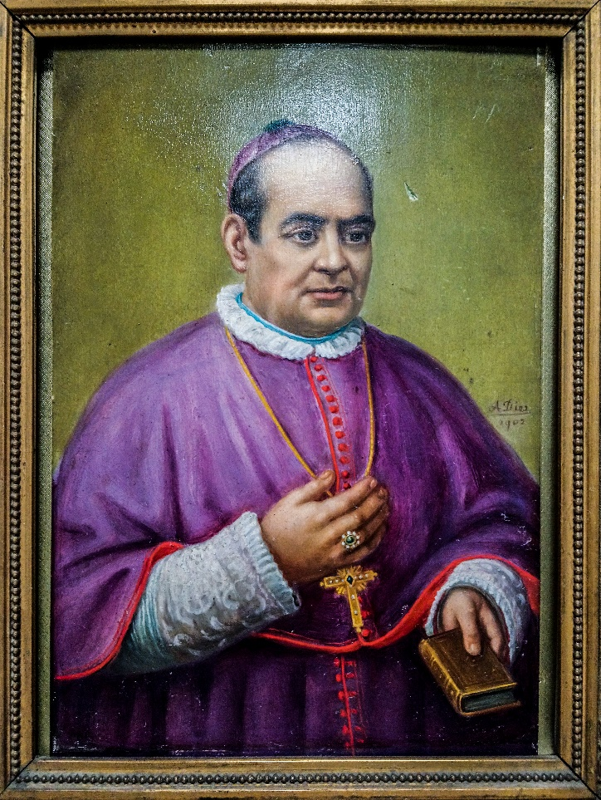
The celebration of the feast of St. Anthony Mary Claret invites us to contemplate how our Founder faithfully lived his vocation in the midst of revolutions and ideological confusions that affected the social fabric and afflicted the people in the 19th century. He died in exile on 24 October 1870 in total availability to the Lord whom he loved, praised, and proclaimed.
The Church of our times has been going through the pain of purification and transformation in the context of the recurrent news of various scandals, a festering wound in the mystical body of Christ. Its eruption into the public arena, our awareness of the hurt of the victims, and the disillusion of the faithful are leading the whole Church, in spite of all the pain it causes us, on the road of purification and renewal. Indeed, as wise men say “If you stand straight, do not fear a crooked shadow.”
Purification and renewal of the Church is an inner work of transformation that enables persons and structures in the Church to become radiant witnesses of the love of Christ. Pope Francis, through his words and deeds, has been inviting the whole Church to such a journey. Recently when certain persons dragged the Pope to the media scrutiny with allegations of cover up of scandals, I wrote a note to the Pontiff on 4th September 2018, in the name of our Congregation, expressing our full communion with him, and our deep affection for his person. In that letter, I assured that the Claretian response to the challenges of our times is by living our life and mission with joy and love of God. I imagine that our Father Founder would want us to be a prophetic presence in the Church with the courage deriving from the word of God to empower the weak and heal the wounds of sin and hate. However, without this transformation in ourselves, we are prone to spend time tending our own ego-wounds of frustrations and dissatisfactions and seeking compensations. Claret reminds us of the source of his pastoral fruitfulness, “if you fall in love with Jesus Christ, you will do greater things”.
We need a three-fold approach to render our Congregation as a dynamic and authentic missionary presence in the Church and in the world:
- Presence: Following the example of our Founder, the first condition of a missionary is to be in constant communion with the Lord, “to be with him and to be sent” (Mk 3:13) in mission to the peripheries. It is only when we are transformed by the presence of the Lord, we become a transforming presence to others. We need to have the “smell of the Good Shepherd” by dwelling in Him when we want to be “shepherds with the smell of the sheep.” I have concerns about the missionaries who spend little time with the Lord in prayer even though they do a lot of activities. Activities become apostolic commitments only when they flow from a heart moved by God’s love for his people. Our presence begins with our own brothers in community and together with them extends to the people in need especially the younger Generations. There is something inherently amiss if a Claretian is not a transforming presence in the place he lives.
- Proclamation: Our Founder proclaimed the Gospel through various means using different platforms. It is the urge of our very missionary identity. Like St. Paul, our heart should whisper, “Woe to me if I do not preach the gospel!” (I Cor 9.6). A professed Claretian is like a lit candle that cannot but radiate its light.
- Practice: The challenge of our time is to live our call with authenticity and transparency amidst scandals and against dehumanizing consumer values. The strength of our Founder was his practice of what he preached. Clarity of vocational values is important, but not sufficient. “To talk much and arrive nowhere is the same as climbing a tree to catch a fish,” says a Chinese proverb. Gospel is not lived in ideas, but in authentic relationships, options, decisions, and behaviours. We should dare to give life to the word through deeds. Pope Francis often speaks of coherence and concreteness as marks of Christian life and love. The Word of God needs to “take flesh” in our “flesh” today, in concrete acts of love, so that people can behold God’s glory in the lived life of Christians.
Memory of our Founder summons us to return to the simplicity and joy of the Gospel, which would mark our everyday life. We unite our hearts with the Pope “to plant dreams, draw forth prophecies and visions, allow hope to flourish, inspire trust, bind up wounds, weave together relationships, awaken a dawn of hope, learn from one another, and create a bright resourcefulness that will enlighten minds, warm hearts, give strength to our hands, and inspire in young people a vision of the future filled with the joy of the Gospel” (Pope Francis, opening address to the Synod of Bishops on Young People, the Faith and Vocational Discernment, October 5, 2018).
Like St. Claret, we shall take to the heart the words of Mary, our Mother, “Do whatever he tells you” (Jn 2.5).
Happy Feast of our Father Founder.
Fr. Mathew Vattamattam, CMF
Superior General
24 October 2018



