2027 WYD Seoul: Pilgrim's Guide to Faith, Culture, and K-Food
Welcome to Seoul! To help you explore the city safely and conveniently during the 2027 World Youth Day, we have prepared a guide to major Catholic shrines, cultural spots, and popular food destinations.
(Note: Transportation fares are based on the 2026 standard adult base fare of approximately $0.97 for subways using a transit card like T-money. Exchange Rate: 1,450won/1dollar)
📱 Essential Tip: Navigation Apps in Korea
Please note that Google Maps has limited walking directions in South Korea due to local security regulations. We highly recommend downloading the following free apps, which offer full English support:
- Naver Map: The most widely used navigation app in Korea. It provides excellent walking, bus, and subway directions in English.
- KakaoMap: Another highly accurate app for real-time transit information and location searches.
- Subway Korea: The best dedicated app for navigating the extensive Seoul subway system with precise transfer guides.
1. Major Catholic Shrines and Pilgrimage Sites
① Myeongdong Cathedral
- Overview: The spiritual heart of the Korean Catholic Church. It is the perfect starting point to experience the dynamism of the local faith.
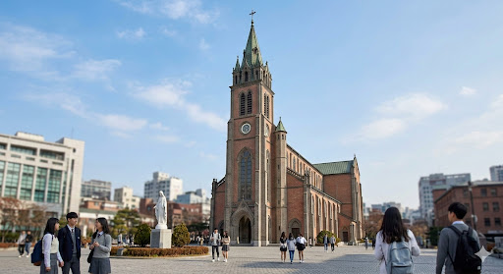
- Transportation: A 10-minute walk from Myeongdong Station (Line 4, Exit 8) or Euljiro 1(il)-ga Station (Line 2, Exit 5).
- Fares: Free admission / Subway base fare: $0.97.
② Seosomun Shrine History Museum
- Overview: The holy ground where the largest number of Catholics were martyred in Korean Church history. The underground museum offers a serene space for meditation and boasts world-class architectural beauty.
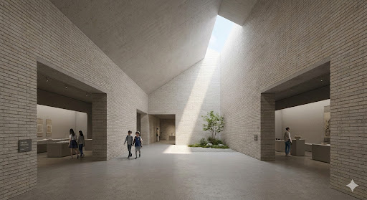
- Transportation: A 10-minute walk from Chungjeongno Station (Lines 2 or 5, Exit 4).
- Fares: Free admission / Subway base fare: $0.97.
③ Jeoldusan Martyrs' Shrine
- Overview: A site commemorating the Byeongin Persecution (1866). Pilgrims can reflect on the firm faith of their ancestors amidst the peaceful scenery along the Han River.
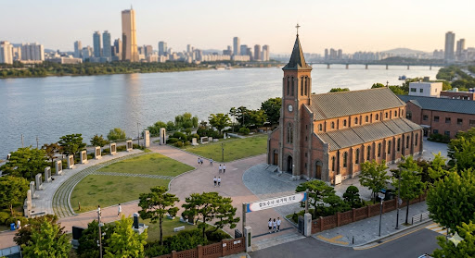
- Transportation: A 15-minute walk toward the Han River from Hapjeong Station (Lines 2 or 6, Exit 7).
- Fares: Free admission / Subway base fare: $0.97.

2. Cultural Experiences & Exchange Venues
① HiKR Ground
- Overview: A K-Pop-themed cultural space. Youth interested in the Korean Wave can take photos and videos in settings that resemble actual K-Pop music video sets.

- Transportation: A 5-minute walk from Jonggak Station (Line 1, Exit 5) or Euljiro 1(il)-ga Station (Line 2, Exit 2).
- Fares: Free admission / Subway base fare: $0.97.
② Bukchon Hanok Village
- Overview: A traditional village featuring beautiful Korean houses (Hanok). It was also a major filming location for the hit 2025 series K-Pop Demon Hunters.
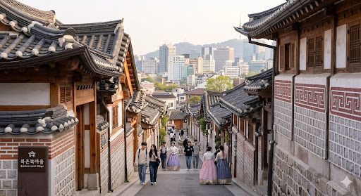
- Transportation: A 10-minute walk from Anguk Station (Line 3, Exit 2). (Please keep noise levels down as it is a residential area).
- Fares: Free admission / Subway base fare: $0.97.
③ Naksan Park and Seoul City Wall
- Overview: A famous spot for enjoying Seoul's beautiful night view while walking along the ancient fortress wall. It is widely known globally as a stunning night-time filming location for K-Pop Demon Hunters.
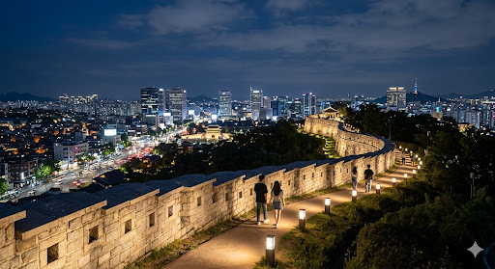
- Transportation: A 15 to 20-minute uphill walk from Hyehwa Station (Line 4, Exit 2).
- Fares: Free admission / Subway base fare: $0.97.
④ Gyeongbokgung Palace
- Overview: Korea's most iconic royal palace. Renting and wearing a traditional Hanbok while strolling through the palace is a highly recommended cultural experience.
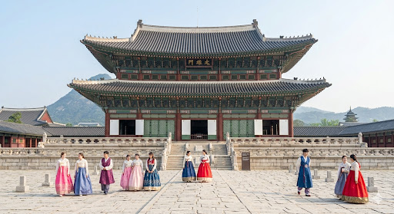
- Transportation: Directly connected to Gyeongbokgung Station (Line 3, Exit 5).
- Fares: Adults $2.07 (Free admission for everyone wearing a Hanbok) / Subway base fare: $0.97.
3. Popular K-Food Experience Spots
① Gwangjang Market
- Overview: A historic traditional market famous for authentic K-Food street culture. Must-try items include Bindaetteok (mung bean pancakes) and Mayak Gimbap.
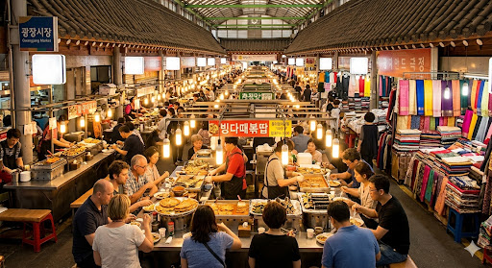
- Transportation: Near Jongno 5(o)-ga Station (Line 1, Exit 8).
- Fares: Free admission (Food costs are paid individually) / Subway base fare: $0.97.
② Myeongdong Street Food Alley
- Overview: Located right next to Myeongdong Cathedral, this bustling street offers trendy snacks popular on social media, such as Dalgona, Hotteok (sweet pancakes), and Tornado Potatoes.
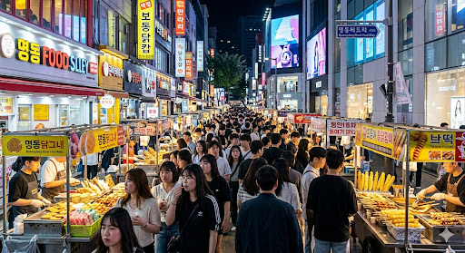
- Transportation: The main street area around Myeongdong Station (Line 4, Exit 6).
- Fares: Free admission (Food costs are paid individually) / Subway base fare: $0.97.
③ Mangwon Market
- Overview: A highly recommended traditional market near the Jeoldusan Shrine. It is famous for Dakgangjeong (sweet crispy fried chicken). Many visitors buy food here for a "Han River Picnic" nearby.
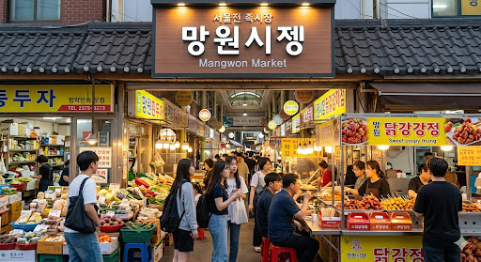
- Transportation: A 10-minute walk from Mangwon Station (Line 6, Exit 2).
- Fares: Free admission (Food costs are paid individually) / Subway base fare: $0.97.
Sources:
- Catholic Archdiocese of Seoul Pilgrimage Route Official English Guide (http://walk.catholic.or.kr/)
- Korea Heritage Service, Gyeongbokgung Palace English Guide (https://royal.khs.go.kr/ENG/)
- Seoul Tourism Organization, Visit Seoul English Guide (https://english.visitseoul.net/)
- Seoul Metro, 2026 Passenger Transport Terms and Fare Table (http://www.seoulmetro.co.kr/en/)
- Naver and Kakao official English service guide (https://mkt.naver.com/navermapapp?lang=en)
- KOREA TOURISM ORGANIZATION (https://english.visitkorea.or.kr/svc/main/index.do)
Useful English Websites for Tourism Reference
- Visit Korea (Official Korea Tourism Organization): https://english.visitkorea.or.kr/
  - Comprehensive guides on travel, accommodations, emergency contacts, and K-culture.
- Visit Seoul (Official Seoul Tourism Guide): https://english.visitseoul.net/
  - Up-to-date information on Seoul's attractions, festivals, tourist information centers, and recommended itineraries.
- Seoul Metro (Official English Website): http://www.seoulmetro.co.kr/en/
  - Interactive subway maps, route planner, station facilities, and fare calculators.
- Korea Heritage Service (Royal Palaces & Tombs): https://royal.khs.go.kr/ENG/
  - Detailed English information on ticketing, operating hours, and free guided tour schedules for all royal palaces.

